The Stuttgart Record
NO 25,187
November 11th, 1938

JEWISH BUSINESSES WERE DESTROYED IN RETALIATION OF VOM RATH’S DEATH
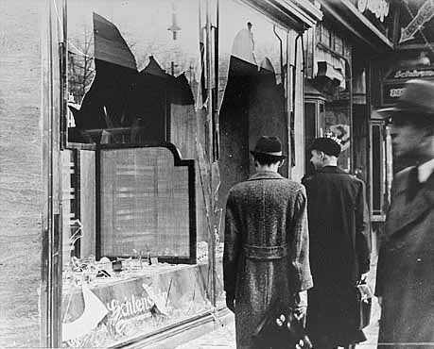
GERMANY, November 9th and 10th— Over the last two days, Jewish shops and buildings all over Germany and other Nazi controlled areas, were raided and ruined The start was all because Ernst Vom Rath, a German Embassy official, was shot and killed by a 17 year old Jewish boy on November 7th.
In what is being called the Kristellnacht, “The Night of Crystal”, all started when Herschel Grynszpan shot Vom Rath. Upon hearing the news that thousands of Polish Citizens living in Germany were expelled, Grynszpan was enraged. His parents had been living in Germany since 1911. When Grynszpan heard that Vom Rath was in Paris, he took action. On November 7th, Grynszpan shot Vom Rath and two days later, Vom Rath died. The death of the official sparked an outburst from the Germans, and the destruction began under Joseph Goebbels instruction. Goebbels told Rioters to destroy anything PHOTO BY--- Elias Muller but German or Non-Jewish people, and to arrest as many Jews as the jails could hold. As well as an estimated total of 7,500 establishments, there were many rapes and suicides as a result of Kristellnacht. Be sure to follow The Kiel Record for more updates on “The Night of Crystal”

